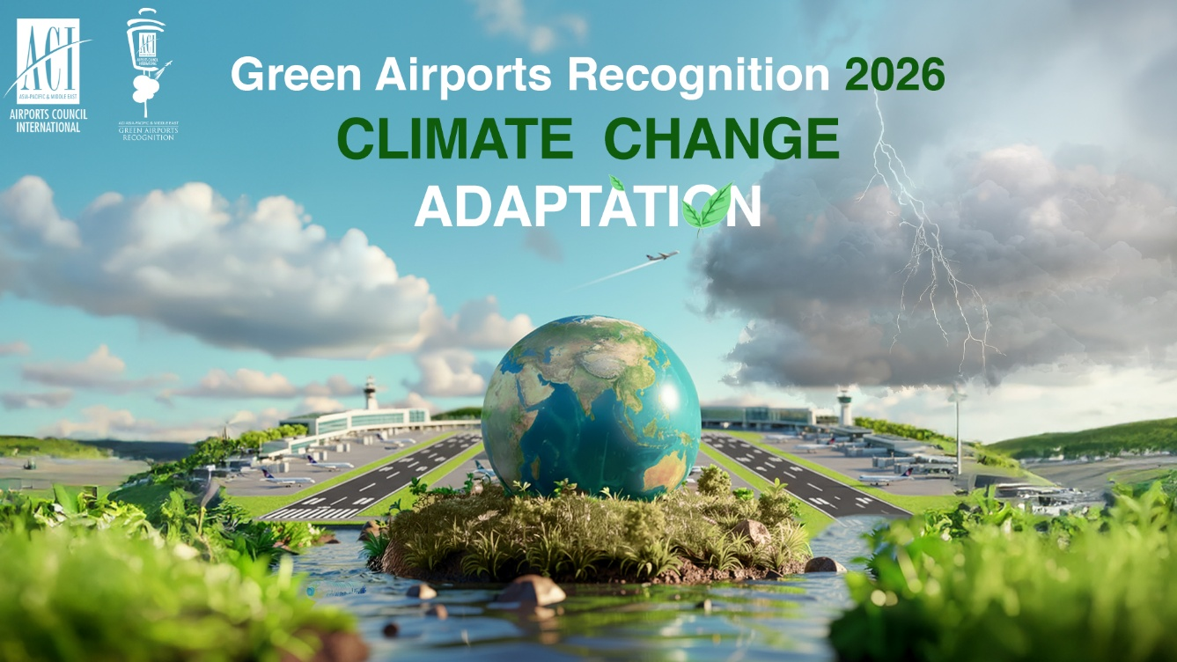
Part I- Programme Description

Background and Objective
The ACI Asia-Pacific & Middle East Green Airports Recognition promotes environmental best practices to minimise aviation’s impact on the environment and recognises airport members who have outstanding accomplishments in environmental projects.
This initiative allows airports to share environmental projects with other airports in the region and be recognised for their achievements.
Initiative Topics - Environment
The environmental field encompasses the following key themes, from which a topic will be selected for the Green Airports Recognition each year:
- Air quality
- Biodiversity
- Carbon
- Climate Change Adaptation
- Energy
- Environmental Policy and Management (including green procurement)
- Ground transportation
- Land & water contamination
- Noise
- Water (including both municipal water usage and wastewater discharge)
- Waste
- Others

Green Airports Recognition 2026: Climate Change Adaptation
Green Airports Recognition (GAR) celebrates its tenth anniversary in 2026, continuing to promote environmental excellence by recognising ACI Asia-Pacific & Middle East (ACI APAC & MID) airport members who have achieved outstanding accomplishments in climate resilience and adaptation.
Building and maintaining resilient infrastructure is crucial alongside efforts to decarbonise assets. Climate change is already impacting airports worldwide; extreme rainfall has disrupted aerodrome operations at airports in the Middle East and Asia-Pacific. Intensifying weather patterns and extreme events are expected to continue, despite global net-zero commitments. The Intergovernmental Panel on Climate Change (IPCC) has also urged governments to prioritise adaptation to mitigate severe climate effects.
Airports are uniquely positioned to lead and showcase climate adaptation efforts, particularly as they face increasing physical impacts of climate change. As extreme weather events and climate-related disruptions become more frequent, there is an increasing need for airports to proactively assess risks and implement adaptation measures.
In response to increased requests from airports for a climate resilience study, ACI APAC & MID initiated a Study on Climate Adaptation Approach for APAC MID airports (2025-2026) to develop a comprehensive climate adaptation approach and practical tools for airports in the region. The common climate hazards identified by airports include sea level rise, extreme temperatures, drought and desertification, wildfires, changes in precipitation, extreme rainfall and flooding, storms and lightning strikes, changing wind patterns, tropical storms, icing and snowfall variations, and fog pattern changes.
Airports can collaborate with key stakeholders, including airlines, ground handling service providers, insurers, and local communities to implement innovative adaptation strategies that enhance resilience and safe operations. The Green Airports Recognition 2026 offers airports in the Asia-Pacific and Middle East regions a chance to demonstrate outstanding accomplishments in climate resilience and adaptation.

The call for Green Airports Recognition 2026 submissions is now open!

All member airports of ACI Asia-Pacific & Middle East, from across Asia-Pacific and the Middle East, are invited to participate by submitting their innovative initiatives and projects on Climate Change Adaptation. We encourage airports to highlight their innovative adaptation measures and best practices aimed at reducing climate risks across a wide range of areas, including infrastructure and building adaptation, operational changes, nature-based solutions, energy and utility resilience, risk management (insurance and finance), staff training, conducting studies on improved technologies, and stakeholder engagement.

Eligibility
- Applicants must be active ACI Asia-Pacific & Middle East’s airport members
- Applicants must complete Environmental Survey 2025
- Submitted project or initiative must be completed within last five years (2021 to 2025)
How to Apply
The participating airport is required to submit the completed application form to ACI Asia-Pacific & Middle East. (Only one project in one application per airport operator)

Important Dates
Submission deadline: 21 December 2025, 12:00 Noon HKG Time (GMT+8)
Result announcement: Within Q1 2026
Presentation ceremony: ACI Asia-Pacific & Middle East Regional Assembly,
Conference and Exhibition (Bangkok, Thailand), May 2026

Judging Process and Criteria
Eligibility review: All applications will be reviewed (project completion date, word limit prescribed etc.) by ACI APAC & MID.
Panel assessment: Each eligible submission will be evaluated based on the judging criteria by a Panel comprising ACI APAC & MID, academia and experts in the airport environmental field worldwide.
Nominated environmental projects will be assessed based on the following seven criteria, on a scale of 0 to 4 (4 = Excellent; 3 = Good; 2 = Satisfactory; 1 = Fair; 0 = No evidence).
- Environmental Awareness & Benefit
- Company Management Involvement
- Cost Effectiveness
- Innovation
- Stakeholder Engagement
- Social Benefit
- Applicability

Award Categories
Platinum, Gold and Silver recognitions will be given to the three highest-scoring airports in each size category (depending on the number of participants) based on the judging criteria.
Selected submissions will be featured in the Green Airports Recognition publication and outstanding airports will be recognised with our sustainability credential and be invited to the award presentation ceremony at the ACI APAC & MID Regional Assembly, Conference and Exhibition 2026 (RACE) in Bangkok on 13 May 2026 along with their achievements highlighted in ACI APAC & MID’s press campaign.

Enquiries
For enquiries, please contact Mr. Ken Lau, Head, Sustainability, and Mr. Mohan Sai Gurugubelli, Manager Sustainability & Environment at green_airports@aci-asiapac.aero
Part II – Application Form
Section A – Entrant Particular
Airport Operator (only 1 project per airport operator):
Airport: | IATA code:
Contact Person (Name & Designation):
Tel. No.: | Email:
Section B – Project details
Project Name: | Completed date:
Website link (if any)
Section C – Declarations
By submission of this form, I agree to the report being published and publicised at the discretion of ACI Asia-Pacific & Middle East. I agree that ACI Asia-Pacific & Middle East and/ or the Panel of Judges have full authority to make final decisions on all matters relating to the “ACI Asia-Pacific & Middle East Green Airports Recognition” without obligation to disclose the reasons.
Signature of Official/ Alternate Representative/ Senior Management: |  | Name:
 |  | Designation:
 |  | Date:
Section D – Important Note
- Please submit (1) a completed Application Form in MS Word and (2) a scanned copy of this page with a signature to green_airports@aci-asiapac.aero on or before 21 December 2025, 12:00 noon Hong Kong Time (GMT+8).
- Please provide details of only one project in one application per airport operator.
- Please contact us if you do not receive an acknowledgement email from the ACI Asia-Pacific & Middle East Regional Office within three working days after your submission.

Executive Summary
Provide a brief summary of the project for ACI’s future publications. (max 300 words)
Project Background
Describe where, when and why the project was needed. (max 100 words)

Project Scope
Describe the operational boundary of the project, e.g. airside only, terminal only, airport-wide etc. and stakeholders involved, e.g. airport staff, regulators, NGOs and environmental groups etc. (max 50 words)

Project Description
Describe how the project was delivered, e.g. retrofit, new project as well as funding.
(max 150 words)

Project Results and Benefits
List your project achievements and supporting evidence and summarize its relevance to the judging criteria, e.g., factual data, actual cost saved, recognized environmental benefits and evidence of innovation. (max 300 words)

Project graphics
Maximum 4 graphics with captions e.g., photos, charts etc. This part will be considered for future ACI publications. Provide a caption for each graphic and keep the graphics within one A4 page.
Caption 1: | Caption 2:
INSERT A PICTURE HERE | INSERT A PICTURE HERE
Caption 3: | Caption 4:
INSERT A PICTURE HERE | INSERT A PICTURE HERE

